14.40: From Eq. (14.17), with 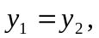
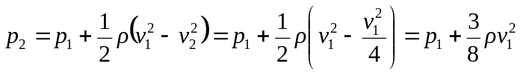
where the continutity relation 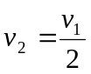has been used.

